09/08/2024 JAVA-CSA0983

1. Find the series in reverse of number using recursion:

Program:

public class Main {

public static void main(String[] args) {

int num = 5;

printReverseSeries(num);

}

public static void printReverseSeries(int num) {

if (num > 0) {

System.out.print(num + " ");

printReverseSeries(num - 1);

}

}

}

Output: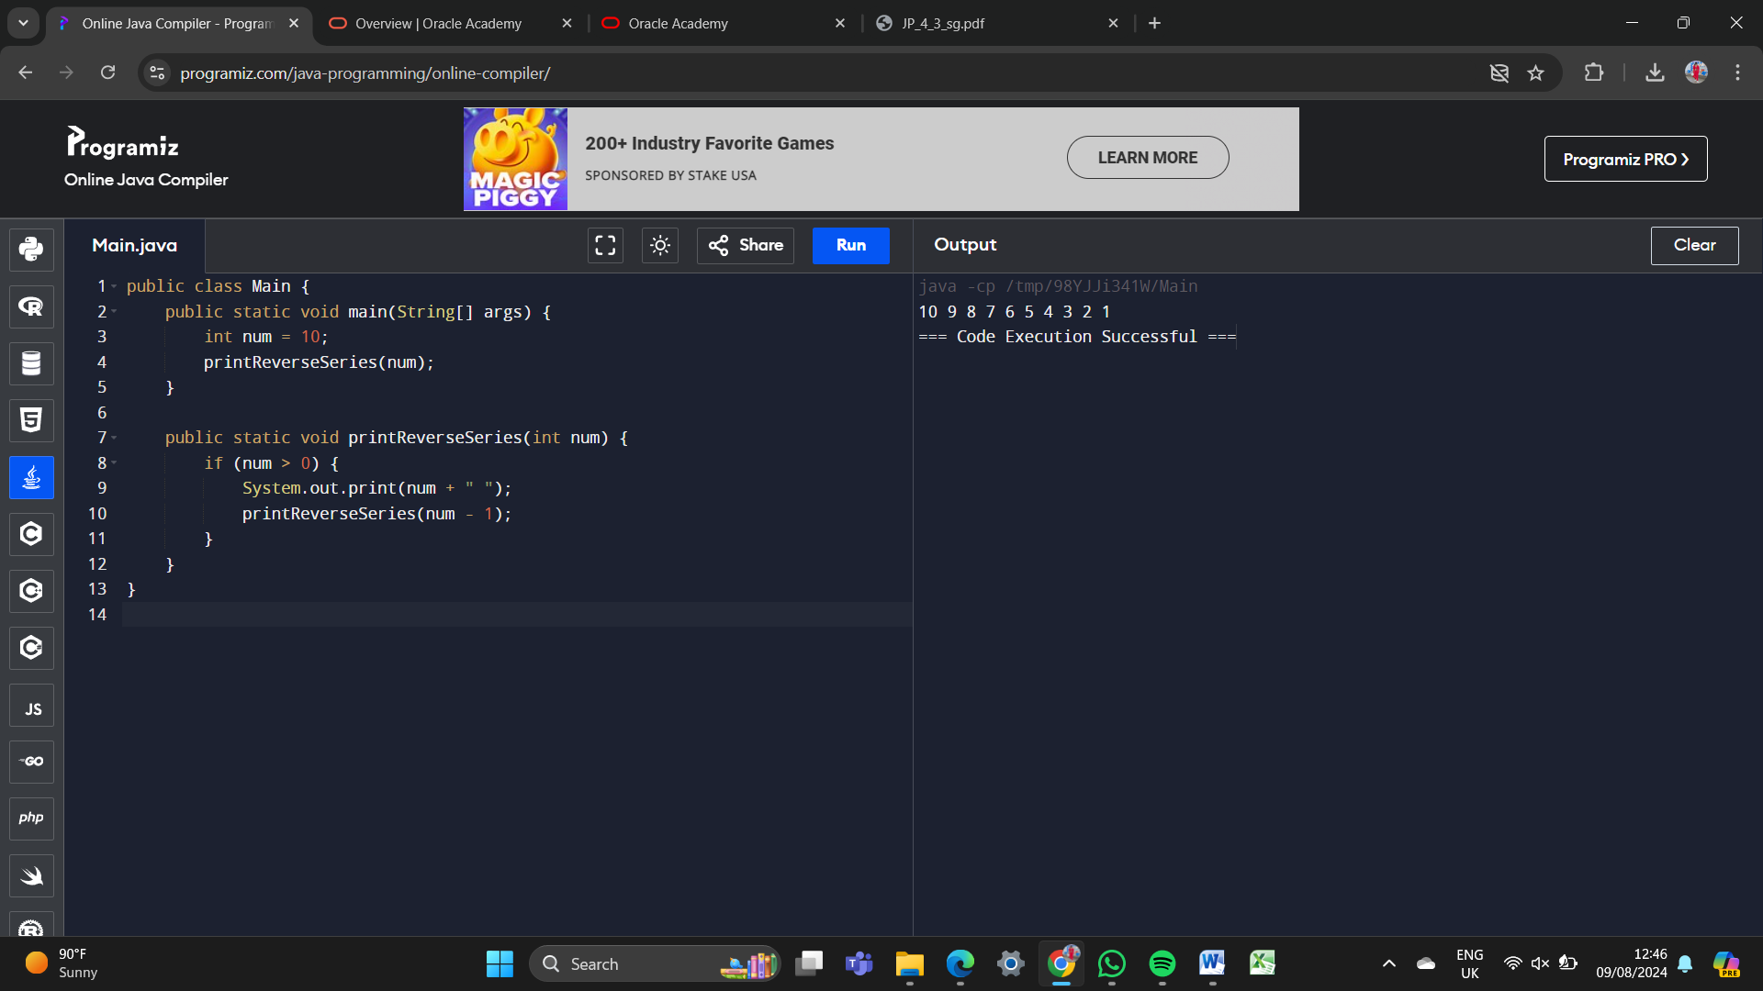

2. Recursive Fibonacci series:

public class Main {

public static void main(String[] args) {

int num = 10;

for (int i = 0; i < num; i++) {

System.out.print(fibonacci(i) + " ");

}

}

public static int fibonacci(int num) {

if (num <= 1) {

return num;

} else {

return fibonacci(num - 1) + fibonacci(num - 2);

}

}

}

Output:

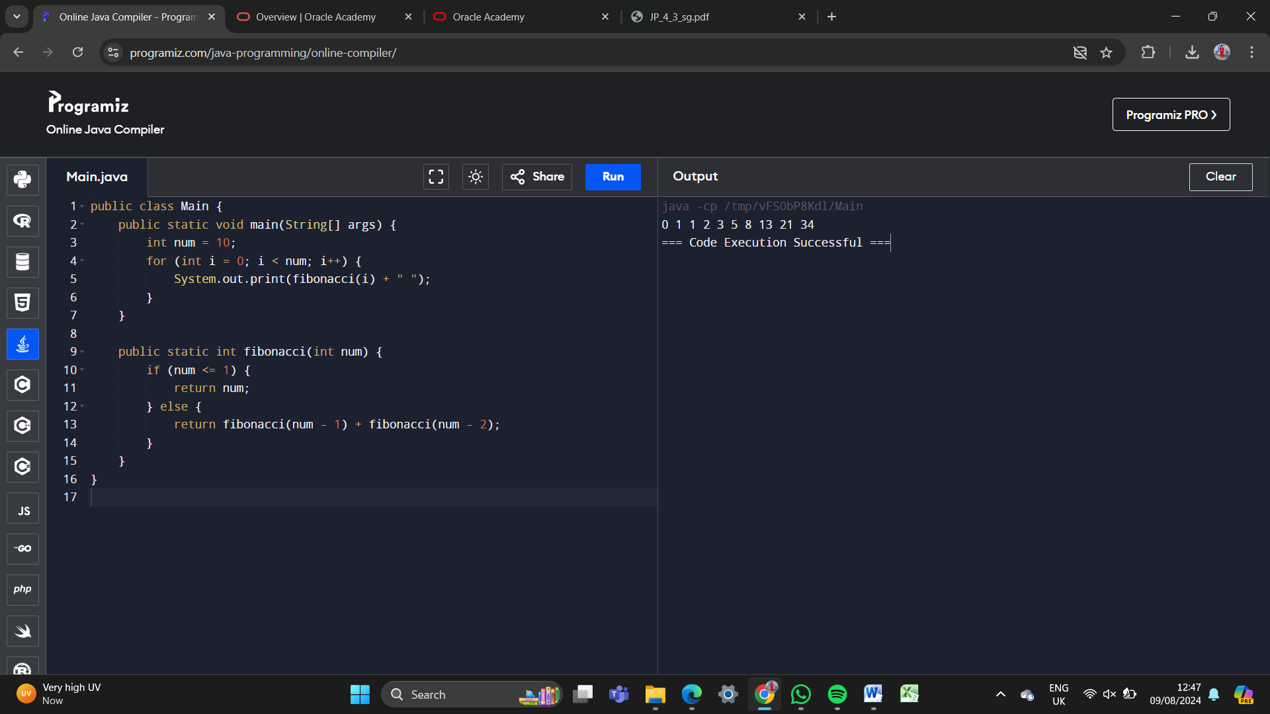

3. Using recursive find the given string is palindrome or not:

public class Main {

public static void main(String[] args) {

String str = "madam";

if (isPalindrome(str, 0, str.length() - 1)) {

System.out.println("Palindrome");

} else {

System.out.println("Not Palindrome");

}

}

public static boolean isPalindrome(String str, int start, int end) {

if (start >= end) {

return true;

}

if (str.charAt(start) != str.charAt(end)) {

return false;

}

return isPalindrome(str, start + 1, end - 1);

}

}

Output:

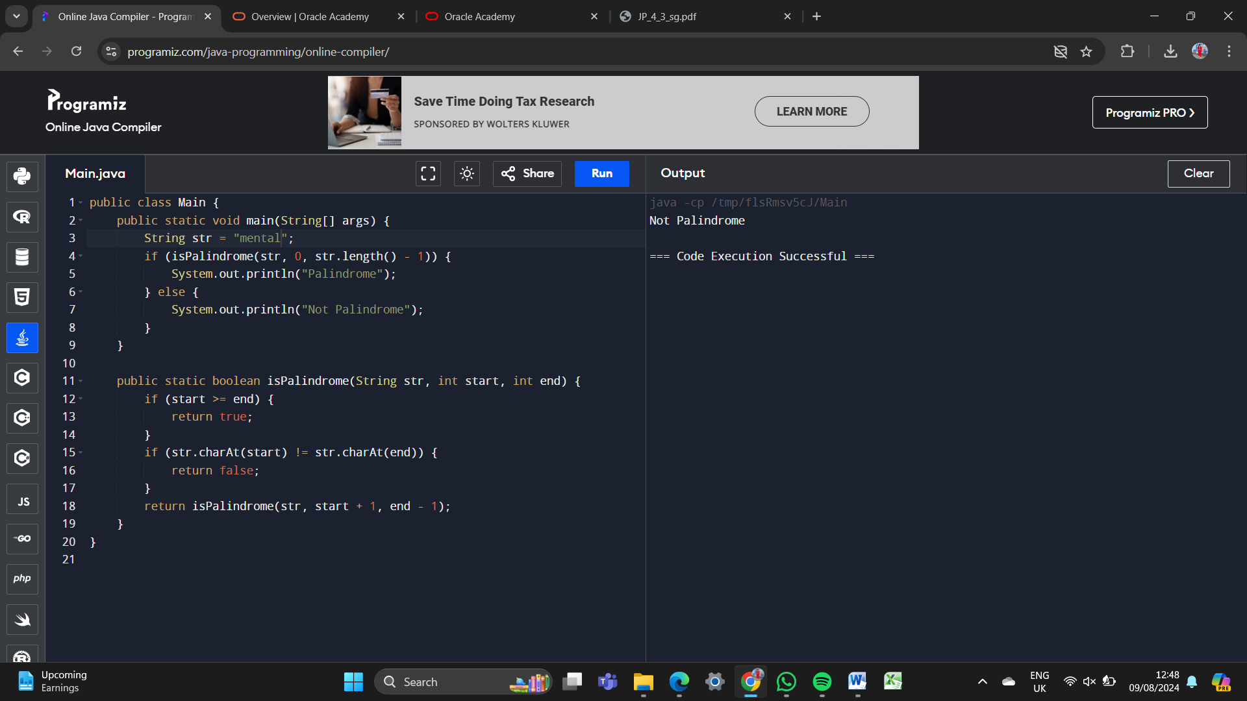

4. Factorial using recursion in Java:

public class Main {

public static void main(String[] args) {

int num = 5;

System.out.println("Factorial: " + factorial(num));

}

public static int factorial(int num) {

if (num == 0 || num == 1) {

return 1;

} else {

return num \* factorial(num - 1);

}

}

}

Output:

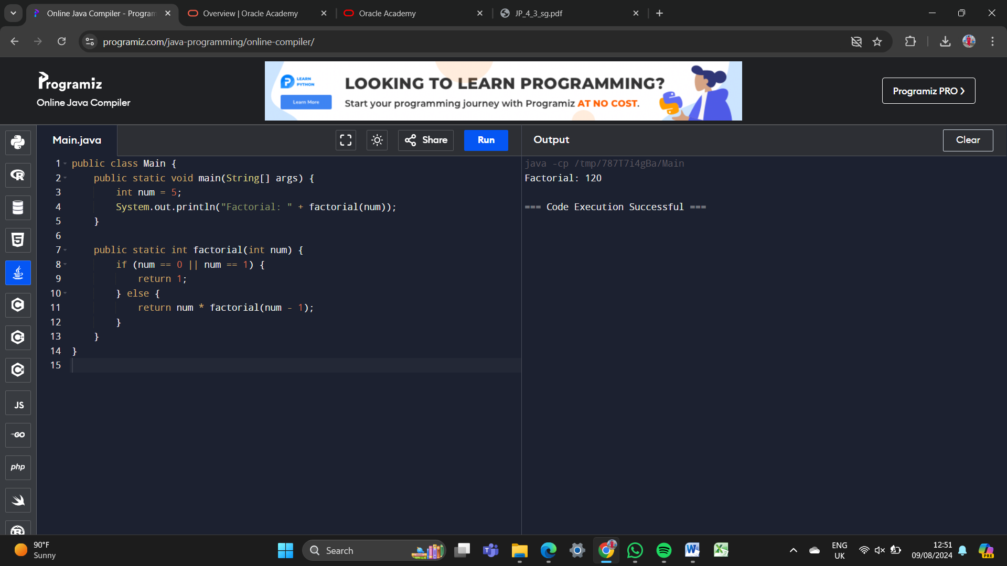

5. Addition of series in java using recursion

public class Main {

public static void main(String[] args) {

int num = 10;

int sum = sumSeries(num);

System.out.println("Sum of series: " + sum);

}

public static int sumSeries(int num) {

if (num == 0) {

return 0;

} else {

return num + sumSeries(num - 1);

}

}

}

Output:

